**Licensing Requirements**

While obtaining an export license for an item is the primary responsibility of the exporter, shippers also share the responsibility to ensure that the export is legal. Apart from the actual transport itself, shippers must be aware of the export/transit controls that apply to the transaction. This means that shippers must be knowledgeable of, and compliant with, licensing regulations and STC legal requirements.

Licensing Requirements: Defining Export/Transit Controls

Export/transit controls are essential for a country's national security, foreign policy, and economic interests. Effective controls involve using preventive and enforcement methods. These methods allow authorities to ensure their compliance and target violations without impeding the flow of legitimate business.

In this guide, references to "export/transit" include a number of circumstances under which goods leave one country destined for another. Export/transit controls are important for a country to prevent the export/transit of sensitive items, which are usually controlled by the government for concerns including:

* Military or WMD applications of the item;
* Destination country, organization, or individual; or
* Declared or suspected end-use or the end-user of the item.

**Export:** Shipment or transmission of items out of the country, to a foreign country.

**Re-Export:** Export of previously imported items.

**Transit:** Imported items en route to another foreign destination, but they stay onboard their means of conveyance. These items do not have a consignee in the country of transit.

**Transshipment:** Imported items that are temporarily unloaded in a country and then reloaded onto the same or another vessel, aircraft, or vehicle, and exported. Like transit items, these items do not have a consignee in the country of transshipment.

Licensing Requirements: Requirement for Export/Transit Controls

It is imperative that a country have both the legal authority and capability to deter, identify, and halt any transfer to end-uses or end-users of proliferation concern - even if the transfer is authorized by another state and only transiting your country.

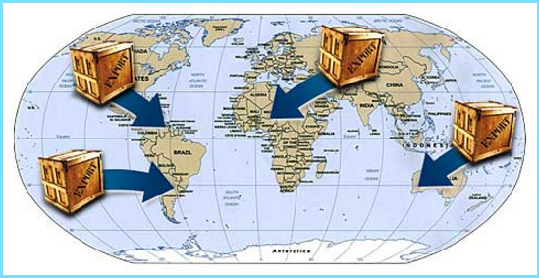

**Export/Transit controls are:**

* Mandated by the UN to prevent the proliferation of WMD
* Accepted international standards and best practices in the international trade community
* Most effective when they are harmonized

**Let us now look at the role of national and EU legislation, and UNSCR 1540 in export/transit controls in detail.**

Licensing Requirements: United Nations Security Council Resolution 1540

[United Nations Security Council Resolution (UNSCR) 1540](http://www.un.org/ga/search/view_doc.asp?symbol=S/RES/1540(2004)) was unanimously adopted in April 2004, in response to growing concerns of terrorism, illicit trafficking, and proliferation. UNSCR 1540 requires all UN members to:

* Adopt national legislation to control the manufacture, possession, and trafficking of WMD and their means of delivery
* Develop and maintain **effective national export, re-export, transshipment, and transit controls over such items,** including controls on providing funds and services regarding export and transshipment

Licensing Requirements: EU Regulatory Requirements

In the EU, shippers have compliance responsibilities under the EU Regulations even when their actions are dependent upon information or instructions given by those who use their services. Chapter I, Article 2 of the ***COUNCIL REGULATION (EC) No 428/2009 of 5 May 2009***setting up a Community regime for the control of exports, transfer, brokering and transit of dual-use provides the following definition of

"**Exporter**," to include shippers: ... "exporter" shall mean any natural or legal person or partnership:

* On whose behalf an export declaration is made, that is to say t**he person who, at the time when the declaration is accepted, holds the contract with the consignee in the third country and has the power for determining the sending of the item out of the customs territory** of the Community. If no export contract has been concluded or if the holder of the contract does not act on its own behalf, **the exporter shall mean the person who has the power for determining the sending of the item out of the customs territory** of the Community;
* Where the benefit of a right to dispose of the dual-use item belongs to a person established outside the Community pursuant to the contract on which the export is based, **the exporter shall be considered to be the contracting party** established in the Community;

Shippers are responsible for the representations they make in filing export data. No person, including an agent, may proceed with any transaction knowing that a violation of the EU Regulations has, is about to, or is intended to occur. **It is the agent's responsibility to understand its obligations.** **Shippers may also be subject to criminal prosecution and/or administrative penalties for violations of the EU Regulations**.

**[Insert the name of your country**]

[Insert national definitions of “exporter” and “export” and any other relevant legal provisions that may apply to shippers. Refer to relevant legislation and legal provisions]

Licensing Requirements: Export or Commodity Classification Number (ECN or CCN)[1]

A CCN or ECN describes a particular item or type of item in technical detail, shows the controls placed on that item, and should appear on export documentation including the export license and accompanying shipping documents. The CCN/ECN is denoted, with the description of the item, on a country’s national control list (NCL).

**The example below (Gravity meters and gravity gradiometers) provides insight into the structure of CCNs:**

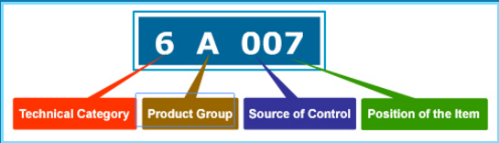

**6** The first character (number) - represents the overall technical category of the item. This character is a digit in the 0 - 9 range.

**A** The second character (letter) represents the product group. This character is a letter ranging A - E.

**0**The third character (number) - indicates the Multilateral Export Control Regime (MECR) from which the item is derived.

**07**The fourth and fifth characters (numbers) - represent the position of the item within the technical category and the product group.

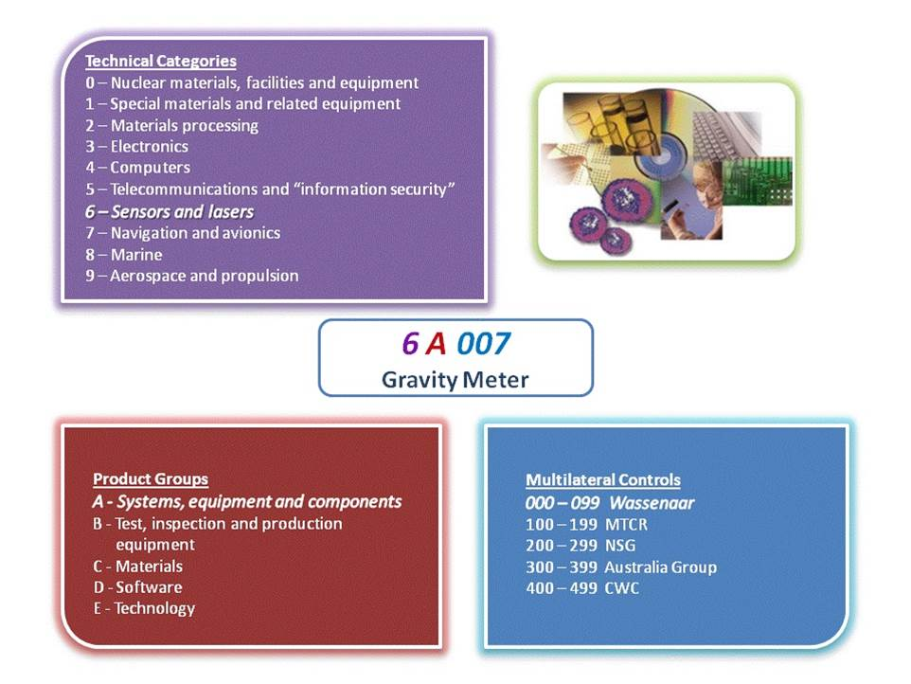

Licensing Requirements: Harmonized System (HS)

National Control Lists (NCLs) are used in a country's export control process. For the import control process, the Harmonized System (HS) is used. The HS is an international method of classifying products for tariff and statistical purposes. It is widely used by Customs officials to determine duties, taxes, and regulations that apply to imports. Under the HS, imports are assigned a six-digit identifying number.

**The example below provides insight into the structure of Harmonized System (HS) codes:**

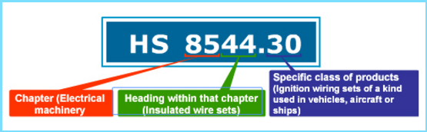

**85** The first two digits of this number identify the chapter into which the product falls.

**44**The second two digits identify the heading within that chapter.

**30**The final two digits identify a specific class of products.

Licensing Requirements: Comparing NCL and HS Entries

A commodity control number (CCN) might describe items that are covered in several HS entries. Similarly, an HS code can cover items described by more than one CCN. However, almost never will the entire coverage of an HS number and the entire coverage of a CCN be identical. HS codes are usually broad and inclusive of multiple commodities, while CCNs tend to be more precise, with technical characteristics and descriptions that are specific to a singular commodity.

**NCL Entries**

* Used to determine whether a particular item requires an export license
* Technology, services, and technical data are classified in the NCL (dual-use or military)
* Covers items (goods, technology, and services) that require export controls

**HS Entries**

* Used for classifying products for tariff and statistical purposes
* Classifies all physical products
* Does not cover technology

Note: *Shippers or agents should avoid making commodity classifications for which they lack technical expertise, and if in doubt should obtain support documentation for the Commodity / Export Classification Number (ECN or CCN).*

If the correlation shows a match between your HS number and a CCN, it is only a possibility, but not a certainty that the item is controlled. In that case you need to carefully read the specified CCN and then determine whether it describes your item or not. The following entry (**Magnetic powder**) illustrates one control number covering items in more than one HS code:

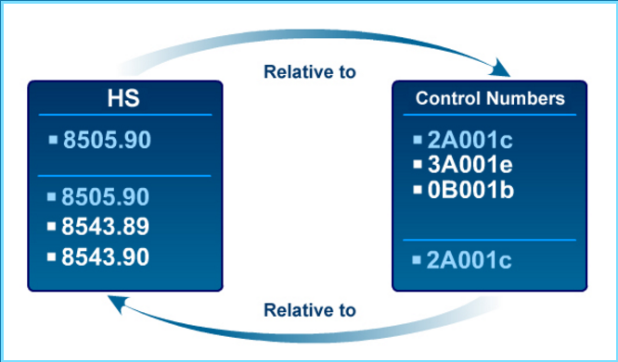

Licensing Requirements: End-User/Foreign Consignee

While obtaining an export license for an item is the primary responsibility of the exporter, shippers are also responsible to ensure that the exports comply with national laws and regulations. Shippers must ensure that they do not export items to prohibited foreign consignees by being knowledgeable about published lists of prohibited end-users and sanctioned groups.



Shippers must also scrutinize packages to ensure that they comply with national laws and be aware of 'red flag' indicators of suspicious activity. If red flags are present, shippers should exercise due diligence in inquiring about the facts of the transaction and ensure that suspicious circumstances are not ignored.

If the red flags cannot be resolved, shippers should refrain from engaging in the transaction. These steps help protect not only the shippers but also the shippers' client, who may be unknowingly engaging in a prohibited transaction.

Licensing Requirements: Exporter vs. Freight Forwarder Responsibilities

***Product classification***

* + Exporters should **classify each product** in accordance with the requirements of the strategic trade control regulations in the country in which they operate. Note: *If the finished product contains controlled U.S.-origin technology, the transaction may also be subject to* ***U.S. extra-territorial re-export controls****.*
  + Exporters should **communicate the appropriate commodity or export classification number** (CCN/ECN) or other classification information for each export **to the trade facilitator or freight forwarder and the end-user** involved in that export.
  + The freight forwarders and logistics enterprises must assure that the information they input in the export related **documents** is **current and accurate**.
  + All (exporting, freight forwarding, and logistics) enterprises involved in the transaction should also **maintain a record of each classification** for every export.

***End-Use and Party Screening***

* All enterprises should **screen all parties to the transaction against all restricted parties lists required under your country’s STC rules** (Examples: national/unilateral restricted party list, UN Consolidated Sanctions List, Japan Foreign End-User of Concern list, or the EU Consolidated List) and maintain records of all screenings.
* All enterprises should **screen all exports/re-exports against a list of embargoed/sanctioned destinations** and maintain records of all such screenings.

***Transit/transshipment hub***

* Enterprises should pay special attention with respect to, from, or through **transit or transshipment hubs** as they may provide opportunity to conceal the true end-user
* All enterprises should have in place compliance and or business procedures to be immediately **responsive to theft or diversion**. This includes procedures such as document confirmation to ensure that the exported item has reached the appropriate end-user.
* All enterprises should pay heightened attention to “**red flag” indicators** and other **indicators of diversion or proliferation risk**.

***Responding to suspicious transactions***

* When any company encounters a suspicious transaction, it should **hold the shipment** and consult with this empowered compliance official.
* If the transaction is determined to involve potential or actual violation of applicable STC regulations, the enterprise should **contact the appropriate government agency** immediately and retain all relevant records.

Licensing Requirements: Non-listed Items and Catch-all Controls

Now that you have a good idea about the NCL and the responsibility for product classification and suspicious transactions, let us focus on the items which are of proliferation concern but are not found on any of the multilateral export control regime (MECR) lists.

A large percentage of the goods and technology required for a project or facility of concern involving WMD or missile delivery systems are not found on the MECR lists. The question is how to curb items which do not appear on any list. This is where **“catch-all” controls** come into play.

Catch-all controls are **based on the end-use or end-user of the item**. These controls create the means of imposing **license requirements on non-listed items**, and are designed to help further prevent the proliferation of WMD and their delivery systems.

Catch-all controls are based on the concept that an export license should be required for any item, regardless of its level of sophistication, which is going to an entity involved in WMD-related activities. Even low-level items (such as test tubes) that are not on any control list might require a license if they are going to an entity or end-use of proliferation concern.

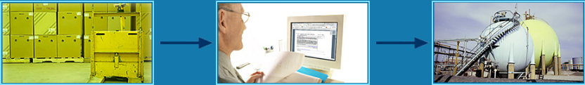

**Item to be exported**

**Filter**

**Chemical plant for making CWs (restricted end-use)**

Note: *Unlike controls imposed pursuant to the NCL, which are based on technical parameters, catch-all controls are based on the potential end-use or end-user of the item and the potential for the item to contribute to a WMD or military program or another unauthorized end-use.*

Catch-all controls supplement the lists of items of the multilateral export control regimes - the Nuclear Suppliers Group (NSG), the Missile Technology Control Regime (MTCR), the Australia Group (AG), and the Wassenaar Arrangement (WA). To be most effective, catch-all controls need to be applied multilaterally, consistent with each country's legal system.

The **European Union has established dual-use transit controls** based on catch-all provisions. COUNCIL REGULATION (EC) No 428/2009 of 5 May 2009setting up a Community regime for the control of exports, transfer, brokering and transit of dual-use items stipulates the following: "The transit of listed dual-use items may be prohibited by the competent authorities of the Member State where the transit occurs if the items are or may be intended, in their entirety or in part, for use in connection with the development, production, handling, operation, maintenance, storage, detection, identification or dissemination of chemical, biological or nuclear weapons or other nuclear explosive devices or the development, production, maintenance or storage of missiles capable of delivering such weapons."

In the **U.S.** export control regulations, an 'Entity List' is published for exporters. Any goods destined for a party who is listed on the Entity List will require an export license under the end-use/end-user control requirement. Additionally, an end-use/end-user licensing requirement exists for end-users not found on the Entity List, but who are known, or suspected, to be involved in WMD-related activities.

Note: *The* [***Restricted Party Screening Tool (RPST)***](http://rpst.rit.albany.edu/)*that is part of this guide will enable your enterprise to screen all parties to a transaction against the EU Consolidated List, U.S. Consolidated List, and the Japan Foreign End-User List. The RPST can also be modified to screen against any unique, unilateral/national list that may be maintained in your country.*

**[Insert name of your country]**

**[**Insert name of your country**]** has established dual-use transit controls [based on catch-all provisions?] set forth by [insert name of relevant STC legislation and relevant article/section]:

“Transit” is defined as: [insert definition of transit as it relates to dual-use items]

License Requirements: Red Flags

Recall that many items of proliferation concern are not found on any multilaterally-defined lists or national control lists. Also, proliferators often **elude detection by using a benign entity name or** **understating the technical capabilities of the item**. Shippers should be alert to any indicators that the exporter intends to export goods to a suspicious end-user or for a suspicious end-use. Such indicators are referred to as 'red flags'.

A red flag is **a warning signal or indicator that there maybe an illegal activity in process, or that items may be en route to a suspicious end-user**. In export/transit control terms, this translates to looking for things that do not seem logical or are falsely described.

**Some examples of red flags include:**

* 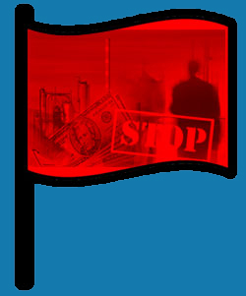A shipper in the chain is not a known or established enterprise
* Products are not compatible with the customer's business
* Listed value is in excess of the fair market value
* Final consignee is a freight forwarder
* Delivery dates are vague or ambiguous
* The shipping route is circuitous and illogical

License Requirements: Know Your Customer

Take into account any abnormal circumstances in a transaction that may indicate that the export may be destined for an inappropriate/restricted end-use, end-user, or destination.

**RED FLAGS -** When red flags are raised in the information that comes to your firm, you have a duty to investigate the suspicious circumstances, and inquire about the end-use, end-user, or country of destination.

**YES**

**NO**

**NO RED FLAGS -** There is no affirmative duty upon shippers to inquire, verify, or otherwise "go behind" the customer's representations.

[**Red Flag Actions**](http://icp.rit.albany.edu/index.php/the-elements-of-an-internal-compliance-program/transaction-screening-process-and-procedures?limitstart=0)

 **Do not self-blind** Do not cut off the flow of information that comes to your firm in the normal course of business. A company is not insulated from liability by taking steps to avoid "bad" information, and it would usually be considered an aggravating factor in an enforcement proceeding. Employees need to know how to handle red flags.

**Knowledge possessed by an employee** of an enterprise can be imputed to a firm so as to make it liable for a violation. This makes it important for firms to establish clear policies and effective compliance procedures to ensure that such knowledge about transactions can be evaluated by responsible senior compliance officials. Failure to do so could be regarded as a form of self-blinding.

**Reevaluate all the information after the order inquiry** - The purpose of this inquiry and reevaluation is to determine whether the red flags can be explained or justified. If they can, you may proceed with the transaction. **If all doubts are not resolved, refrain from the transaction, disclose the information to your firm’s CCO or the government authorities** and wait.”

Note: *The Implementation Aids section of the ICP Guide contains red flag checklists, diversion risk checklists, and other practical screening resources that may assist your enterprise. Please* [***click here***](http://icp.rit.albany.edu/index.php/implementation-resources/icp-implementation-aids?start=3) *to access these materials.*

Licensing Requirements: Additional Precautions

In addition to red flags, shippers should also be aware of the **package handling instructions**. Sometimes the **signage on the package can warrant further investigation**. Often, the products in such packages will be on the control list, and will require an export or transit license.

**Some examples of the categories that merit attention by the shippers include:**

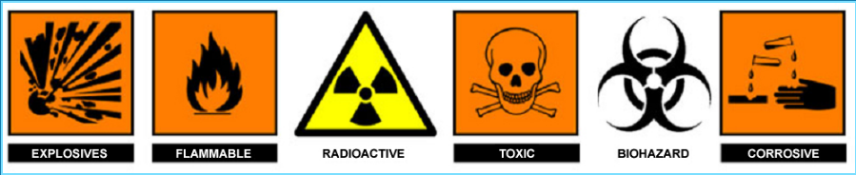

Licensing Requirements: Assessing Transaction Risks

**The graphic below provides a “risk matrix” based on various indicators. A risk matrix can be useful tool to assist your enterprise in determining the level of risk associated with a transaction.**

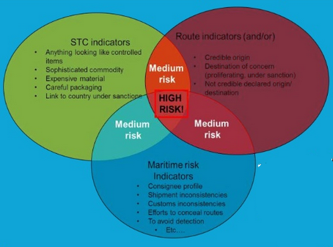

Note: *The Implementation Aids section of the ICP Guide contains a risk matrix and a diversion risk checklist, and other practical resources that may assist your enterprise in screening transactions. Please* [***click here***](http://icp.rit.albany.edu/index.php/implementation-resources/icp-implementation-aids?start=3) *to access these materials.*

1. Note: *The ICP Guide relies on the term “Commodity Classification Number (CCN) and Export Classification Number (ECN)” throughout. Commodity Control Number (CCN), Export Control Number (ECN) or Export Control Classification Number (ECCN). Your enterprise should determine the appropriate and recognized term utilized in your country. Some countries use the term.*